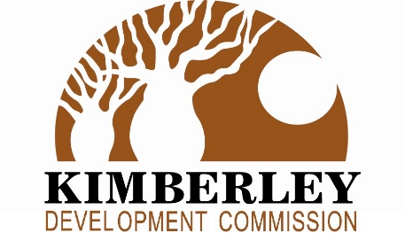

KIMBERLEY COMMUNITY ACTION FUND

Frequently Asked Questions

General

- What is the Kimberley Community Action Fund (KCAF) Grants Program?

The Kimberley Community Action Fund (KCAF) program invests in community driven projects that contribute to local solutions to reduce crime in the Kimberley region.

- What can KCAF Grants funding be used for?

The KCAF program provides funding to support locally driven projects that will address crime issues in Kimberley communities by reducing crime, improving community safety and security, providing engaging activities and places for young people at risk of offending and to enhance community empowerment. The Guidelines provide further details. Further clarification can be sought from the Regional Development Commission.

Applications

- How can I apply?

Download guidelines information under the Our Focus/Grants tab on the Kimberley Development Commission website www.kdc.wa.gov.au.

Applicants are to contact the Grants Officer at the Kimberley Development Commission for more information on project eligibility and advice prior to completing the application form – Tel: 08 91248 2100 or email gpo@kdc.wa.gov.au .

- What is the closing date?

Applications for the KCAF grants open 10 July 2023 and close 31 August 2023 at 4:00pm WST.

Completed applications are to be lodged via the SmartyGrants link on the Kimberley Development Commission website.

- How much funding can I apply for?

Projects can request funding of up to $100,000 under the KCAF program.

- What if I am not registered for GST?

Applicants can still apply for grants if they are not registered for GST concessions. Unregistered grant applicants must provide the Kimberley Development Commission with a budget for the amount of the grant inclusive of all project costs including GST.

If you are not registered for GST concessions and need further clarification please contact the Kimberley Development Commission prior to submitting your application.

- Can my organisation apply for full project funding?

Yes, but LGA’s, schools and private businesses are required to provide 50% cash contribution. Not-for-profit organisations will be considered on a case-by-case basis.

- How are applications assessed and how soon after applying will I know if I am successful or not?

We undertake a rigorous assessment process of all applications. Applicants should allow two months for the KCAF approval process which should be considered by applicants during project planning.

The assessment criteria and decision making process used to assess applications are provided in the KCAF guidelines. Assessors are required to declare any potential conflicts of interest.

- How many applications will be awarded with KCAF funding?

There is no cap on the number of successful applications. However, there are limited funds available for the region.

